

Department | FED
Subject | DSA-2
Academic Year | I-III Semester(2025-26)
Faculty Name | Gopi Krishna
Student Name | V Sri Bhargavi
Roll Number | 2520040048
Branch | ECE
Course Outcome | 1

Case Study Topic: Shortest Delivery Route Prediction using Dijkstra’s Algorithm

Work Done Summary:

We used Dijkstra’s Algorithm to compute the shortest path from a warehouse to multiple delivery locations. The weighted graph represented route distances between cities. By iteratively selecting the nearest unvisited city, the algorithm built the shortest-distance tree for all routes.

Implementation Details:
- Represented city routes using an adjacency matrix.
- Initialized distance values to infinity except for the source.
- Selected the minimum distance vertex in each iteration.
- Updated the distances of all adjacent vertices.
- Recorded shortest paths to each city.
- Compared Dijkstra results with manual distance calculation.
Result: Screenshots :
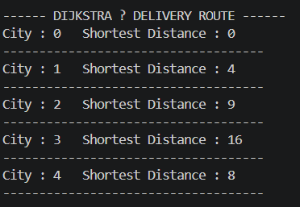
Dijkstra’s Algorithm computed the shortest delivery routes from the warehouse (Node 0).
The shortest distances obtained were:
City 0 → 0, City 1 → 4, City 2 → 9, City 3 → 16, City 4 → 8
Time Complexity:
• Using adjacency matrix: O(V²)
GitHub Link: https://github.com/sribhargavivaddavalli-svg/DSA_CASESTUDIES

